Turtle Graphics and L-systems Informatics 1 – Introduction to Computation Functional Programming Tutorial 7

### Week 7 (28 Oct - 01 Nov.)

Assessment is formative, meaning that marks from coursework do not contribute to the final mark. But coursework is not optional. If you do not do the coursework you are unlikely to pass the exams.

Attendance at tutorials is obligatory; please send email to [lambrose@ed.ac.uk](mailto:lambrose@ed.ac.uk) if you cannot join your assigned tutorial.

# Setup

For this weeks exercises to work properly we need to display graphics by using the Haskell package “GLUT”. This needs to be installed manually.

1. Open a terminal of your choice.
2. Update the “cabal” database by executing the following command:

cabal update

1. Use cabal to install the “GLUT” package by executing the following command:

cabal install GLUT

# 1 Turtle graphics

Turtle graphics is a simple way of making line drawings.The turtle has a given location on the canvas and is facing in a given direction. A command describes a sequence of actions to be undertaken by a turtle, including moving forward a given distance or turning through a given angle.

Turtle commands can be represented in Haskell using an algebraic data type:

type Distance = Float type Angle = Float

data Command = Go Distance

| Turn Angle

| Sit

| Command :#: Command

The last line declares an infix data constructor. We have already seen such constructors in Tutorial 6, where we used them for the binary connectives of propositional logic. While ordinary constructors must begin with a capital letter, infix constructors must begin with a colon. Here, we have used the infix constructor :#: to join two commands.

Thus, a command has one of four forms:

Go d, where d is a distance — move the turtle the given distance in the direction it is facing. (**Note:** distances are not expected to be negative.)

*•*

* Turn a, where a is an angle — turn the turtle anticlockwise through the given angle.
* Sit — do nothing: leaves the turtle’s position and direction unchanged.

p :#: q, where p and q are themselves commands — execute the two given commands in sequence.

*•*

For instance, to draw an equilateral triangle with sides of thirty units, we need to order the turtle to move forward three times, turning 120*◦* between moves (see Figure 1):

Go 30 :#: Turn 120 :#: Go 30 :#: Turn 120 :#: Go 30

Turn 120



Go 30

Go 30

Turn 120

Go 30

Start

Figure 1: Drawing a triangle with turtle commands

## Viewing paths

You can view a turtle’s path by typing:

*Main> display pathExample

where pathExample is an expression of type Command. This will open a new graphics window and draw the turtle graphic. For instance, pathExample has already defined for you as:

pathExample = (Go 30 :#: Turn 120 :#: Go 30 :#: Turn 120 :#: Go 30)

draws the triangle described above.

### Notes:

When you close the graphics window, GHCi will exit as well, so you will need to re-load or re-open your code to draw another picture.

*•*

You should close the graphics window before restarting, if you are running Haskell from an editor; otherwise the editor may freeze.

*•*

For Mac users: If you try to run the display command you will get probably an error, to work around this follow the instructions below:

*•*

* Compile the code in the terminal with ghc --make turorial7.hs.
* Run the code with ./tutorial7.
* To terminate your application type ctrl-C ctrl-C in the terminal window.
* In case that a new black window pops up, try to minimize and then maximize it again, then you should be able to see the figure.

## Equivalences

Note that :#: is an associative operator with identity Sit. So we have:

p :#: Sit = p

Sit :#: p = p

p :#: (q :#: r) = (p :#: q) :#: r

We can omit parentheses in expressions with :#: because, wherever they are placed, the meaning remains the same. In this assignment, when we say that two commands are *equivalent* we mean that they are the same according to the equalities listed above.

However, to evaluate an expression Haskell has to place parentheses; if you ask it to show a command, it will also show where it has placed them:

*Main> Sit :#: Sit :#: Sit Sit :#: (Sit :#: Sit)

### Exercise 1

In this first exercise we will explore the equivalence of turtle commands and convert them into lists and back.

1. Write a function

split :: Command -> [Command]

that converts a command to a list of individual commands containing no :#: or Sit

elements. For example,

*Main> split (Go 3 :#: Turn 4 :#: Go 7) [Go 3, Turn 4, Go 7]

1. Write a function

join :: [Command] -> Command

that converts a list of commands into a single command by joining the elements together. For example,

*Main> join [Go 3, Turn 4, Go 7] Go 3 :#: Turn 4 :#: Go 7 :#: Sit

As in all our examples, the result can be any command equivalent to the given command.

1. Note that two commands are equivalent, in the sense of the equivalence laws above, if

split returns the same result for both.

*Main> split ((Go 3 :#: Turn 4) :#: (Sit :#: Go 7)) [Go 3, Turn 4, Go 7]

*Main> split (((Sit :#: Go 3) :#: Turn 4) :#: Go 7) [Go 3, Turn 4, Go 7]

Write a function equivalent that tests two commands for equivalence. Give both its type and definition.

1. Write two QuickCheck properties to test split and join. The first should check that join (split c) is equivalent to c, where c is an arbitrary command. The second should check that the list returned by split contains no Sit and (:#:) commands. You need to give the type as well as the definition of both test properties.

### Exercise 2

Using the above translation from lists, we will write a function to draw regular polygons.

1. Write a function

copy :: Int -> Command -> Command

which given an integer and a command returns a new command consisting of the given number of copies of the given command, joined together. Thus, the following two com- mands should be equivalent:

copy 3 (Go 10 :#: Turn 120)

Go 10 :#: Turn 120 :#: Go 10 :#: Turn 120 :#: Go 10 :#: Turn 120

1. Using copy, write a function

pentagon :: Distance -> Command

that returns a command which traces a pentagon with sides of a given length. The following two commands should be equivalent:

pentagon 50

and

Go 50.0 :#: Turn 72.0 :#:

Go 50.0 :#: Turn 72.0 :#:

Go 50.0 :#: Turn 72.0 :#:

Go 50.0 :#: Turn 72.0 :#:

Go 50.0 :#: Turn 72.0

1. Write a function

polygon :: Distance -> Int -> Command

that returns a command that causes the turtle to trace a closed path making a regular polygon with the given number of sides, of the specified length. Thus, the following two commands should be equivalent:

polygon 50 5

pentagon 50

*Hint* : You may need to use the Prelude function fromIntegral to convert an Int to a

Float.

### Exercise 3

Next, we will approximate a spiral, by making our turtle travel increasing (or decreasing) lengths and turning slightly in between. Our function copy is of no help here, since the distance our turtle needs to travel changes after each corner it takes. Therefore, your spiral function will have to be recursive. Its type signature should be as follows:

spiral :: Distance -> Int -> Distance -> Angle -> Command

Its parameters are

* side, the length of the first segment,
* n, the number of line segments to draw,
* step, the amount by which the length of successive segments changes, and
* angle, the angle to turn after each segment.

To draw such a spiral, we draw n line segments, each of which makes angle angle with the previous one; the first should be as long as side and thereafter each one should be longer by step (or shorter, if step is negative).

Thus, the following two commands should be equivalent:

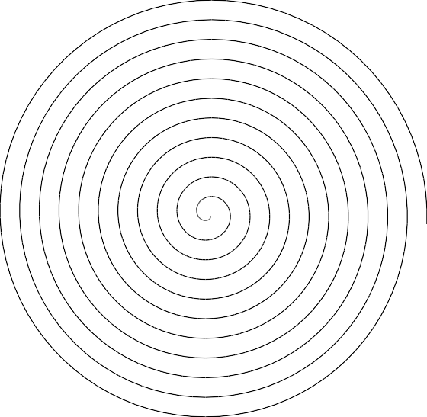

Figure 2: A spiral (spiral 0.1 1000 0.1 4)

spiral 30 4 5 30

Go 30.0 :#: Turn 30.0 :#:

Go 35.0 :#: Turn 30.0 :#:

Go 40.0 :#: Turn 30.0 :#:

Go 45.0 :#: Turn 30.0

**Note:** your recursion should definitely stop after n steps (the second parameter), but you will also need to keep in mind that line segments should not become negative in length.

Sample output is shown in Figure 2.

### Exercise 4

Besides the equalities we saw earlier, we might also want to consider the following ones:

Go 0 = Sit

Go d :#: Go e = Go (d+e) Turn 0 = Sit

Turn a :#: Turn b = Turn (a+b)

So the Sit command is equivalent to either moving or turning by zero, and any sequence of consecutive moves or turns can be collapsed into a single move or turn (as long as moves have a non-negative distance!). Write a function:

optimise :: Command -> Command

which, given a command p, returns a command q that draws the same picture, but has the following properties:

* q contains no Sit, Go 0 or Turn 0 commands, unless the command is equivalent to Sit.
* q contains no adjacent Go commands.
* q contains no adjacent Turn commands. For example:

*Main> optimise (Go 10 :#: Sit :#: Go 20 :#:

Turn 35 :#: Go 0 :#: Turn 15 :#: Turn (-50))

Go 30.0

*Hints:* You can use split and join to make your task easier. If your version of join adds a Sit command, you will need to define a new version which does not. Remember that Go does not take negative arguments.

# Branching and colours

So far we’ve only been able to draw linear paths; we haven’t been able to branch the path in any way. In the next section, we will make use of two additional command constructors:

data Command = ...

| GrabPen Pen

| Branch Command

where Pen is defined as:

data Pen = Colour Float Float Float

| Inkless

These give two additional forms of path.

GrabPen p, where p is a pen: causes the turtle to switch to a pen of the given colour. The following pens are predefined:

*•*

white, black, red, green, blue :: Pen

You can create pens with other colours using the Colour constructor, which takes a value between 0 and 1*.*0 for each of the red, green and blue components of the colour. The special Inkless pen makes no output; you can use Inkless to create disjoint pictures with a single command.

Branch p, where p is a path: draws the given path and then returns the turtle to direction and position which it had at the *start* of the path (rather than leaving it at the end). Pen changes within a branch have no effect outside the branch.

*•*

To see the effect of branching, draw the following path.

let inDirection angle = Branch (Turn angle :#: Go 100) in join (map inDirection [20,40..360])

## Introduction to L-Systems

The Swedish biologist Aristid Lindenmayer developed *L-Systems* to model the development of plants.1

An L-System consists of a *start pattern* and a set of *rewrite rules* which are recursively applied to the pattern to produce further increasingly complex patterns. For example, Figure 3 was produced from the “triangle” L-System:

angle: 90

start: +f

rewrite: f *→* f+f-f-f+f

1 For more on L-Systems, see <http://en.wikipedia.org/wiki/L-System>. A book, *The Algorithmic Beauty of Plants*, contains beautiful color illustrations produced by L-Systems; it is available online at <http://algorithmicbotany.org/papers/#abop>

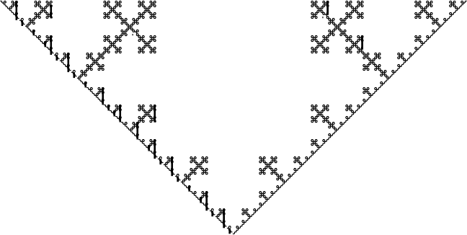

Figure 3: Triangle L-System output

Each symbol in the string generated by an L-System represents a path command: here, + and - represent clockwise and anticlockwise rotation and f represents a forward movement. Which symbols represent which commands is a matter of convention.

In this system, only the symbol f is rewritten, while the + and - symbols are not. The rewriting replaces the straight lines with more complex figures.

Here is how to generate a picture with an L-System. Begin with the start pattern. Then apply the rewrite rule some number of times, replacing the character on the left by the sequence on the right. For instance, applying the above rule three times gives the following strings in successive steps:

### Step Pattern

0 +f

1 +f+f-f-f+f

2 +f+f-f-f+f+f+f-f-f+f-f+f-f-f+f-f+f-f-f+f+f+f-f-f+f

+f+f-f-f+f+f+f-f-f+f-f+f-f-f+f-f+f-f-f+f+f+f-f-f+f

+f+f-f-f+f+f+f-f-f+f-f+f-f-f+f-f+f-f-f+f+f+f-f-f+f

1. -f+f-f-f+f+f+f-f-f+f-f+f-f-f+f-f+f-f-f+f+f+f-f-f+f

-f+f-f-f+f+f+f-f-f+f-f+f-f-f+f-f+f-f-f+f+f+f-f-f+f

+f+f-f-f+f+f+f-f-f+f-f+f-f-f+f-f+f-f-f+f+f+f-f-f+f

Note that you could continue this process for any number of iterations.

After rewriting the string the desired number of times, replace each character that remains by some drawing commands. In this case, replace f with a move forward (say, by 10 units), replace each + by a clockwise turn through the given angle, and replace each - by an anticlockwise turn through the given angle.

Converting L-Systems to functions that return turtle commands is straightforward. For example, the function corresponding to this “triangle” L-System can be written as follows:

triangle :: Int -> Command triangle x = p :#: f x

where

f 0 = Go 10

f x = f (x-1) :#: p :#: f (x-1) :#: n :#: f (x-1)

:#: n :#: f (x-1) :#: p :#: f (x-1)

n = Turn 90

p = Turn (-90)

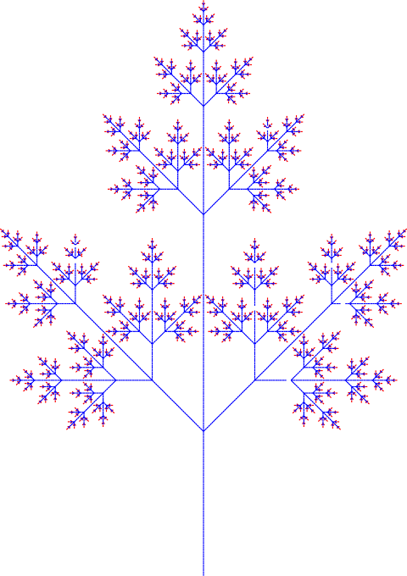

Figure 4: Tree L-System output

Study the above definition and compare it with the L-System definition on the previous page. The above definition is included in LSystem.hs, so you can try it out by typing (for instance):

display (triangle 5)

A couple of things are worth noting. The symbols from the system that are rewritten are imple- mented as functions that take a “step number” parameter—in this case, only f is rewritten. When we have taken the desired number of steps, the step number bottoms-out at 0, and here f is just in- terpreted as a drawing command. The symbols that are not rewritten are implemented as variables, such as n and p. In general, there will be one definition in the where clause for each letter in the L-System.

A rewrite rule for the L-System may contain clauses in square brackets, which correspond to branches. For example, here is a second L-System, that uses two letters and branches.

angle: 45

start: f

rewrite: f *→* g[-f][+f][gf]

g *→* gg

Here is the corresponding code (also included in LSystem.hs). tree :: Int -> Command

tree x = f x where

f 0 = GrabPen red :#: Go 10

f x = g (x-1) :#: Branch (n :#: f (x-1))

:#: Branch (p :#: f (x-1))

:#: Branch (g (x-1) :#: f (x-1)) g 0 = GrabPen blue :#: Go 10

g x = g (x-1) :#: g (x-1) n = Turn 45

p = Turn (-45)

A picture generated by this definition is shown in Figure 4. Here we use different pens to draw the segments generated by different symbols: this is not part of the description of the L-system, but it generates prettier pictures.

### Exercise 5

Write a function arrowhead :: Int -> Command implementing the following L-System: angle: 60

start: f

rewrite: f *→* g+f+g

g *→* f-g-f

### Exercise 6

Write a function snowflake :: Int -> Command implementing the following L-System (see Sec- tion 2.1):

### Exercise 7

angle: 60

start: f--f--f--

rewrite: f *→* f+f--f+f

Write a function hilbert :: Int -> Command implementing the following L-System (see Sec- tion 2.1):

angle: 90

start: l

rewrite: l *→* +rf-lfl-fr+

r *→* -lf+rfr+fl-

**Note:** Not all of the symbols here need to move the turtle. Check your result against the pictures at <http://en.wikipedia.org/wiki/Hilbert_curve>and adjust the final values (e.g. r 0 = ...) until it looks like those.

# 3 Optional Material

Just for fun, here are more L-Systems for you to try.

* Peano-Gosper:

angle: 60

start: f

rewrite: f *→* f+g++g-f--ff-g+

g *→* -f+gg++g+f--f-g

* Cross
* Branch

angle: 90

start: f-f-f-f-

rewrite: f *→* f-f+f+ff-f-f+f

angle: 22.5

start: g

rewrite: g *→* f-[[g]+g]+f[+fg]-g f *→* ff

* 32-segment

angle: 90

start: F+F+F+F

rewrite: F -F+F-F-F+F+FF-F+F+FF+F-F-FF+

*→*

FF-FF+F+F-FF-F-F+FF-F-F+F+F-F+